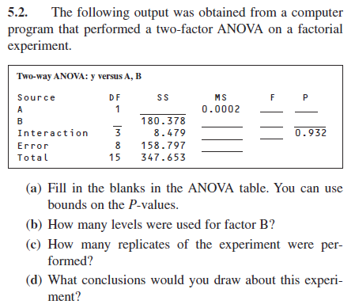

|  |  |  |  |  |  |  |
| --- | --- | --- | --- | --- | --- | --- |
| Source | DF | SS | MS | F* | $$F_{0.5}$$ | P-Value |
| A | 1 | 0.0002 | 0.0002 | $$1.01 ×{10}^{-5}$$ | 5.52 | 0.998 |
| B | 3 | 180.378 | 60.126 | 3.03 | 4.07 | 0.09 |
| Interaction | 3 | 8.479 | 2.826 | 0.14 | 4.07 | 0.933 |
| Error | 8 | 158.797 | 19.580 |  |  |  |
| Total | 15 | 347.653 |  |  |  |  |

4 levels were used for factor B (3 DF + 1)

Conducted over 2 replications

We can conclude that neither factor A, Factor B, or the interaction between A and B have a significant effect on the mean response

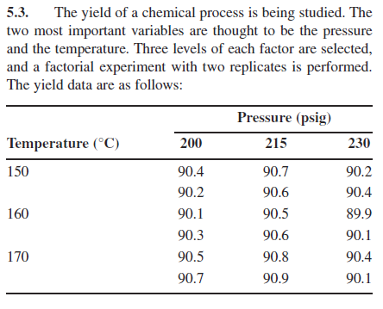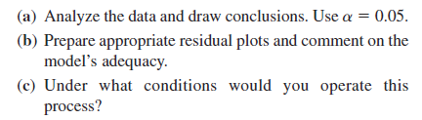

|  |
| --- |
| ***Two-way ANOVA for Problem 5.3*** |
| ***y = Yield, a = PSI, b = Temp*** |

|  |
| --- |
| ***The GLM Procedure*** |

|  |
| --- |
| ***Dependent Variable: y Yield*** |

| **Source** | **DF** | **Sum of Squares** | **Mean Square** | **F Value** | **Pr > F** |
| --- | --- | --- | --- | --- | --- |
| **Model** | 8 | 1.13777778 | 0.14222222 | 8.00 | 0.0026 |
| **Error** | 9 | 0.16000000 | 0.01777778 |  |  |
| **Corrected Total** | 17 | 1.29777778 |  |  |  |

| **Source** | **DF** | **Type I SS** | **Mean Square** | **F Value** | **Pr > F** |
| --- | --- | --- | --- | --- | --- |
| **a** | 2 | 0.76777778 | 0.38388889 | 21.59 | 0.0004 |
| **b** | 2 | 0.30111111 | 0.15055556 | 8.47 | 0.0085 |
| **a*b** | 4 | 0.06888889 | 0.01722222 | 0.97 | 0.4700 |

From the above SAS output we can see that the F-Statistic for factor A (Temp) is 21.59 with 2 and 9 degrees of freedom. The corresponding P-Value is less than α = 0.05 so we can conclude that the Temperature used has a significant effect on yield.

The F-Statistic for factor B (PSI) is 8.47 with 2 and 9 degrees of freedom. The corresponding P-Value is less than α = 0.05 so we can conclude that the day effect is significant.

Additionally, the F-Statistic for the interaction effect is 0.97 with 4 and 9 degrees of freedom. The corresponding P-Value is larger than α = 0.05 so we conclude that the interaction effect between Factor A and Factor B is not significant.



From the above SAS generated interaction plot we can see that there is no significant interaction between Temperature and PSI. This can also be seen in the ANOVA table where the F-Statistic for the interaction effect is 0.97 with 4 and 9 degrees of freedom, and the corresponding P-Value is larger than α = 0.05







| **Levene's Test for Homogeneity of y Variance ANOVA of Squared Deviations from Group Means** | | | | | |
| --- | --- | --- | --- | --- | --- |
| **Source** | **DF** | **Sum of Squares** | **Mean Square** | **F Value** | **Pr > F** |
| **a** | 2 | 0.00134 | 0.000668 | 0.62 | 0.5506 |
| **Error** | 15 | 0.0161 | 0.00108 |  |  |

| **Levene's Test for Homogeneity of y Variance ANOVA of Squared Deviations from Group Means** | | | | | |
| --- | --- | --- | --- | --- | --- |
| **Source** | **DF** | **Sum of Squares** | **Mean Square** | **F Value** | **Pr > F** |
| **b** | 2 | 0.00435 | 0.00217 | 0.64 | 0.5428 |
| **Error** | 15 | 0.0512 | 0.00342 |  |  |

The above SAS generated residual plots indicate that variance is constant, and this is reinforced by the Levene Tests. The Levene’s tests for Homogeneity of Variance for both Temperature and PSI have a F-Statistics of 0.62 with 2 and 15 degrees of freedom and 0.64 with 2 and 15 degrees of freedom respectively. Both tests have P-Values > α = 0.05 which indicates that the variance for Temperature and PSI are constant.

|  |
| --- |
| ***Normal Tests for Problem 5.3*** |
| ***y = Yield, a = Temp, b = PSI*** |

| **Tests for Normality** | | | | |
| --- | --- | --- | --- | --- |
| **Test** | **Statistic** | | **p Value** | |
| **Shapiro-Wilk** | **W** | 0.873664 | **Pr < W** | 0.0205 |
| **Kolmogorov-Smirnov** | **D** | 0.196859 | **Pr > D** | 0.0647 |
| **Cramer-von Mises** | **W-Sq** | 0.176839 | **Pr > W-Sq** | 0.0092 |
| **Anderson-Darling** | **A-Sq** | 1.038595 | **Pr > A-Sq** | 0.0078 |

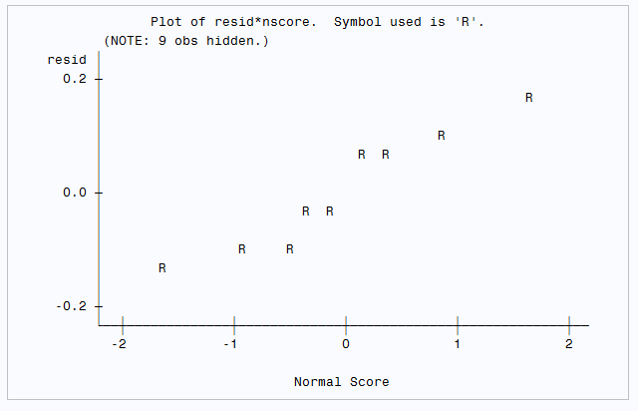

| **Tests for Normality (No Interaction)** | | | | |
| --- | --- | --- | --- | --- |
| **Test** | **Statistic** | | **p Value** | |
| **Shapiro-Wilk** | **W** | 0.981976 | **Pr < W** | 0.9681 |
| **Kolmogorov-Smirnov** | **D** | 0.096731 | **Pr > D** | >0.1500 |
| **Cramer-von Mises** | **W-Sq** | 0.030841 | **Pr > W-Sq** | >0.2500 |
| **Anderson-Darling** | **A-Sq** | 0.188523 | **Pr > A-Sq** | >0.2500 |

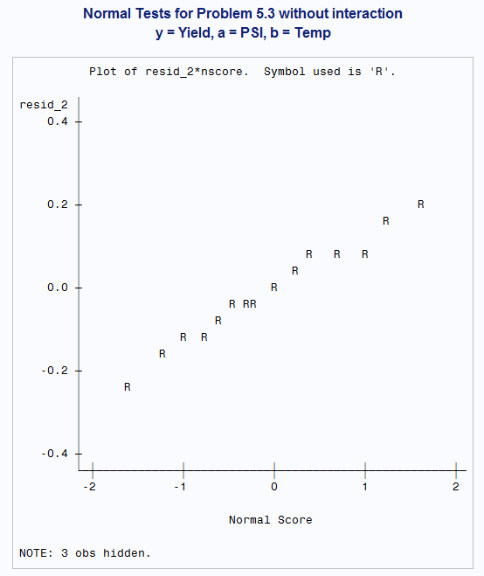From the above tests for normality we can see that while the residuals are not considered Normally distributed by the Shapiro-Wilk test with a P-Value of 0.0205 we can see that the normality plot looks linear. Multiple comparison using Tukey is robust to non-normal data. However, since the interaction is not significant, we will remove the interaction and check for normality again

Since the variance is normally distributed with constant variance, we can conclude that this is an appropriate model. We will continue with the multiple comparison using Tukey. From the above interaction plot and ANOVA table we can see that the interaction effect is not significant. Since the interaction is not significant, we will only perform multiple comparison on the overall effect.

|  |
| --- |
| ***Tukey Multiple Comparison for PSI Problem 5.3*** |
| ***y = Yield, a = PSI, b = Temp*** |

|  |
| --- |
| ***The GLM Procedure*** |

|  |
| --- |
| ***Tukey's Studentized Range (HSD) Test for y*** |

|  |  |
| --- | --- |
| **Alpha** | 0.05 |
| **Error Degrees of Freedom** | 9 |
| **Error Mean Square** | 0.017778 |
| **Critical Value of Studentized Range** | 3.94840 |
| **Minimum Significant Difference** | 0.2149 |

|  |  |
| --- | --- |
| **Alpha** | 0.05 |
| **Error Degrees of Freedom** | 9 |
| **Error Mean Square** | 0.017778 |
| **Critical Value of Studentized Range** | 3.94840 |
| **Minimum Significant Difference** | 0.2149 |

| **Comparisons significant at the 0.05 level are indicated by ***.** | | | | |
| --- | --- | --- | --- | --- |
| **a Comparison** | **Difference Between Means** | **Simultaneous 95% Confidence Limits** | |  |
| **215 - 230** | 0.50000 | 0.28508 | 0.71492 | *** |
| **200 - 215** | -0.31667 | -0.53159 | -0.10174 | *** |
| **200 - 230** | 0.18333 | -0.03159 | 0.39826 |  |

| **Comparisons significant at the 0.05 level are indicated by ***.** | | | | |
| --- | --- | --- | --- | --- |
| **b Comparison** | **Difference Between Means** | **Simultaneous 95% Confidence Limits** | |  |
| **150 - 170** | -0.15000 | -0.36492 | 0.06492 |  |
| **150 - 160** | 0.16667 | -0.04826 | 0.38159 |  |
| **160 - 170** | -0.31667 | -0.53159 | -0.10174 | *** |

From the above SAS output we can see that for the PSI Factor the Tukey Critical Value is 3.94840 with degrees of freedom 3 and 9 and the MSD is 0.2149. We can see that the mean difference between Temperature levels **215 – 200 is** 0.3167**, 215 – 230** is0.5000. Bothof these differences are significant according to the Tukey MSD.

From the above SAS output we can see that for the Temperature Factor the Tukey Critical Value is 3.94840 with degrees of freedom 3 and 9 and the MSD is 0.2149. We can see that the only significant mean difference between Temperature levels **160-170** which is-0.31667**.**



If we consider the above interaction plot, I would recommend that the experiment be run at a temperature of 215 and a PSI of 90.8. These conditions will produce the maximum yield.

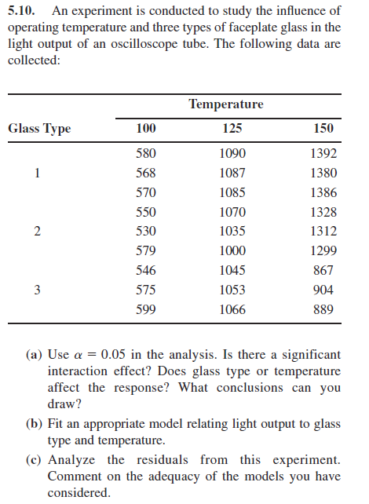

|  |
| --- |
| ***Two-way ANOVA for Problem 5.10*** |
| ***Y = Light Output, A = Temp, B = Glass Type***  ***Dependent Variable: Y Light Output*** |

| **Class Level Information** | | |
| --- | --- | --- |
| **Class** | **Levels** | **Values** |
| **A** | 3 | 100 125 150 |
| **B** | 3 | 1 2 3 |

|  |  |
| --- | --- |
| **Number of Observations Read** | 27 |
| **Number of Observations Used** | 27 |

| **Source** | **DF** | **Sum of Squares** | **Mean Square** | **F Value** | **Pr > F** |
| --- | --- | --- | --- | --- | --- |
| **Model** | 8 | 2411750.741 | 301468.843 | 824.77 | <.0001 |
| **Error** | 18 | 6579.333 | 365.519 |  |  |
| **Corrected Total** | 26 | 2418330.074 |  |  |  |

| **Source** | **DF** | **Type I SS** | **Mean Square** | **F Value** | **Pr > F** |
| --- | --- | --- | --- | --- | --- |
| **B** | 2 | 150864.519 | 75432.259 | 206.37 | <.0001 |
| **A** | 2 | 1970334.519 | 985167.259 | 2695.26 | <.0001 |
| **B*A** | 4 | 290551.704 | 72637.926 | 198.73 | <.0001 |

From the above SAS output we can see that the F-Statistic for factor A (Temp) is 2695.26 with 2 and 18 degrees of freedom. The corresponding P-Value is less than α = 0.05 so we can conclude that the Temperature used has a significant effect on Light Output.

The F-Statistic for factor B (Glass Type) is 206.37 with 2 and 18 degrees of freedom. The corresponding P-Value is less than α = 0.05 so we can conclude that the day effect is significant.

Additionally, the F-Statistic for the interaction effect is 198.73 with 4 and 18 degrees of freedom. The corresponding P-Value is smaller than α = 0.05 so we conclude that the interaction effect between Factor A and Factor B is significant.





From the above interaction plot we can see that the interaction between factor A and B is significant. We can also see that the interaction is significant from the ANOVA table.







| **Levene's Test for Homogeneity of Y Variance ANOVA of Squared Deviations from Group Means** | | | | | |
| --- | --- | --- | --- | --- | --- |
| **Source** | **DF** | **Sum of Squares** | **Mean Square** | **F Value** | **Pr > F** |
| **A** | 2 | 1.385E10 | 6.9257E9 | 15.21 | <.0001 |
| **Error** | 24 | 1.093E10 | 4.553E8 |  |  |

| **Levene's Test for Homogeneity of Y Variance ANOVA of Squared Deviations from Group Means** | | | | | |
| --- | --- | --- | --- | --- | --- |
| **Source** | **DF** | **Sum of Squares** | **Mean Square** | **F Value** | **Pr > F** |
| **B** | 2 | 2.692E10 | 1.346E10 | 2.95 | 0.0716 |
| **Error** | 24 | 1.096E11 | 4.5653E9 |  |  |

From the above Levene’s tests we can see that the residuals for the Temperature Factor is constant but the residuals for the Glass Type factor are **not** constant. This violates the model assumption of equal variance and must be addressed.

We will attempt to stabilize the variance by performing 3 transformations on the Light Output results. We will consider a Square Root Transformation, a Log Transformation, and an Inverse Transformation.

***Y = Light Output, A = Temp, B = Glass Type, Z = Log(Y)***

| **Levene's Test for Homogeneity of Z Variance ANOVA of Squared Deviations from Group Means** | | | | | |
| --- | --- | --- | --- | --- | --- |
| **Source** | **DF** | **Sum of Squares** | **Mean Square** | **F Value** | **Pr > F** |
| **A** | 2 | 0.00904 | 0.00452 | 14.56 | <.0001 |
| **Error** | 24 | 0.00745 | 0.000311 |  |  |

| **Levene's Test for Homogeneity of Z Variance ANOVA of Squared Deviations from Group Means** | | | | | |
| --- | --- | --- | --- | --- | --- |
| **Source** | **DF** | **Sum of Squares** | **Mean Square** | **F Value** | **Pr > F** |
| **B** | 2 | 0.0295 | 0.0148 | 1.83 | 0.1825 |
| **Error** | 24 | 0.1938 | 0.00808 |  |  |

***Y = Light Output, A = Temp, B = Glass Type, W = SQRT(Y)***

| **Levene's Test for Homogeneity of W Variance ANOVA of Squared Deviations from Group Means** | | | | | |
| --- | --- | --- | --- | --- | --- |
| **Source** | **DF** | **Sum of Squares** | **Mean Square** | **F Value** | **Pr > F** |
| **A** | 2 | 696.2 | 348.1 | 14.95 | <.0001 |
| **Error** | 24 | 558.7 | 23.2774 |  |  |

| **Levene's Test for Homogeneity of W Variance ANOVA of Squared Deviations from Group Means** | | | | | |
| --- | --- | --- | --- | --- | --- |
| **Source** | **DF** | **Sum of Squares** | **Mean Square** | **F Value** | **Pr > F** |
| **B** | 2 | 1708.1 | 854.1 | 2.34 | 0.1176 |
| **Error** | 24 | 8746.5 | 364.4 |  |  |

***Y = Light Output, A = Temp, B = Glass Type, V = 1/(Y)***

| **Levene's Test for Homogeneity of V Variance ANOVA of Squared Deviations from Group Means** | | | | | |
| --- | --- | --- | --- | --- | --- |
| **Source** | **DF** | **Sum of Squares** | **Mean Square** | **F Value** | **Pr > F** |
| **A** | 2 | 5.95E-15 | 2.97E-15 | 12.70 | 0.0002 |
| **Error** | 24 | 5.62E-15 | 2.34E-16 |  |  |

| **Levene's Test for Homogeneity of V Variance ANOVA of Squared Deviations from Group Means** | | | | | |
| --- | --- | --- | --- | --- | --- |
| **Source** | **DF** | **Sum of Squares** | **Mean Square** | **F Value** | **Pr > F** |
| **B** | 2 | 4.27E-14 | 2.13E-14 | 1.09 | 0.3511 |
| **Error** | 24 | 4.68E-13 | 1.95E-14 |  |  |

From the above Levene’s Test for Homogeneity of Variance we can see that the transformation that best stabilizes the variance of Factor A is the Inverse Transformation. While this test still produces a P-Vaue < 0.05 we will proceed with the multiple comparison and normality tests. However, these results should be used with caution.

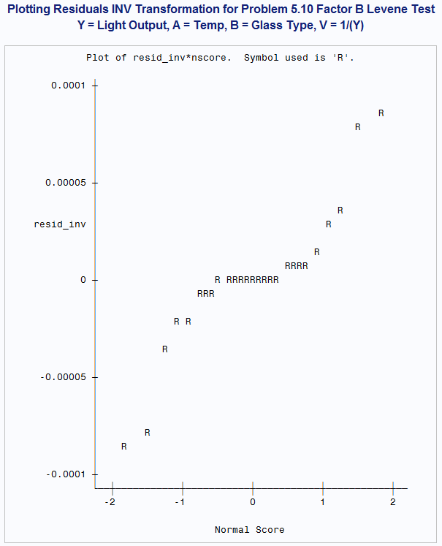

| **Tests for Normality** | | | | |
| --- | --- | --- | --- | --- |
| **Test** | **Statistic** | | **p Value** | |
| **Shapiro-Wilk** | **W** | 0.861772 | **Pr < W** | 0.0020 |
| **Kolmogorov-Smirnov** | **D** | 0.214365 | **Pr > D** | <0.0100 |
| **Cramer-von Mises** | **W-Sq** | 0.32339 | **Pr > W-Sq** | <0.0050 |
| **Anderson-Darling** | **A-Sq** | 1.72981 | **Pr > A-Sq** | <0.0050 |

From the above tests for normality we can see that while the residuals are not considered Normally distributed by the Shapiro-Wilk test with a P-Value of 0.0205 we can see that the normality plot looks roughly linear. Multiple comparison using Tukey is robust to non-normal data so we will proceed with the multiple comparisons.

***Y = Light Output, A = Temp, B = Glass Type, V = 1/(Y)***

| **Source** | **DF** | **Sum of Squares** | **Mean Square** | **F Value** | **Pr > F** |
| --- | --- | --- | --- | --- | --- |
| **Model** | 8 | 4.7777719E-6 | 5.9722149E-7 | 353.26 | <.0001 |
| **Error** | 18 | 3.0431051E-8 | 1.6906139E-9 |  |  |
| **Corrected Total** | 26 | 4.808203E-6 |  |  |  |

| **Source** | **DF** | **Type III SS** | **Mean Square** | **F Value** | **Pr > F** |
| --- | --- | --- | --- | --- | --- |
| **B** | 2 | 9.7744765E-8 | 4.8872383E-8 | 28.91 | <.0001 |
| **A** | 2 | 4.4648653E-6 | 2.2324326E-6 | 1320.49 | <.0001 |
| **B*A** | 4 | 2.1516189E-7 | 5.3790472E-8 | 31.82 | <.0001 |

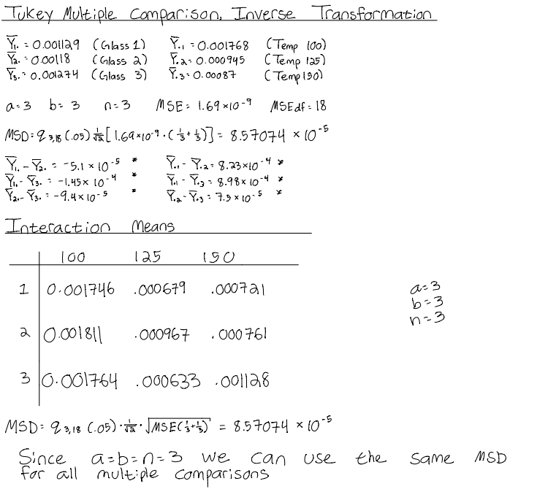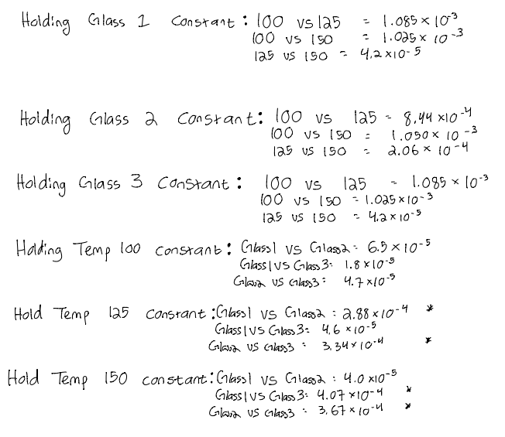

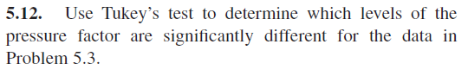

|  |
| --- |
| ***Tukey Multiple Comparison for PSI Problem 5.3*** |
| ***y = Yield, a = PSI, b = Temp*** |

|  |
| --- |
| ***The GLM Procedure*** |

|  |
| --- |
| ***Tukey's Studentized Range (HSD) Test for y*** |

|  |  |
| --- | --- |
| **Alpha** | 0.05 |
| **Error Degrees of Freedom** | 9 |
| **Error Mean Square** | 0.017778 |
| **Critical Value of Studentized Range** | 3.94840 |
| **Minimum Significant Difference** | 0.2149 |

|  |  |
| --- | --- |
| **Alpha** | 0.05 |
| **Error Degrees of Freedom** | 9 |
| **Error Mean Square** | 0.017778 |
| **Critical Value of Studentized Range** | 3.94840 |
| **Minimum Significant Difference** | 0.2149 |

| **Comparisons significant at the 0.05 level are indicated by ***.** | | | | |
| --- | --- | --- | --- | --- |
| **a Comparison** | **Difference Between Means** | **Simultaneous 95% Confidence Limits** | |  |
| **215 - 230** | 0.50000 | 0.28508 | 0.71492 | *** |
| **200 - 215** | -0.31667 | -0.53159 | -0.10174 | *** |
| **200 - 230** | 0.18333 | -0.03159 | 0.39826 |  |

| **Comparisons significant at the 0.05 level are indicated by ***.** | | | | |
| --- | --- | --- | --- | --- |
| **b Comparison** | **Difference Between Means** | **Simultaneous 95% Confidence Limits** | |  |
| **150 - 170** | -0.15000 | -0.36492 | 0.06492 |  |
| **150 - 160** | 0.16667 | -0.04826 | 0.38159 |  |
| **160 - 170** | -0.31667 | -0.53159 | -0.10174 | *** |

From the above SAS output we can see that for the PSI Factor the Tukey Critical Value is 3.94840 with degrees of freedom 3 and 9 and the MSD is 0.2149. We can see that the mean difference between Temperature levels **215 – 200 is** 0.3167**, 215 – 230** is0.5000. Bothof these differences are significant according to the Tukey MSD.

From the above SAS output we can see that for the Temperature Factor the Tukey Critical Value is 3.94840 with degrees of freedom 3 and 9 and the MSD is 0.2149. We can see that the only significant mean difference between Temperature levels **160-170** which is-0.31667**.**

It should be noted that all these results should be used with caution. The transformations performed did not stabilize the variance for PSI and the residuals are the inverse transformation a not normally distributed. Further transformations may be required or the experiment should be redesigned.

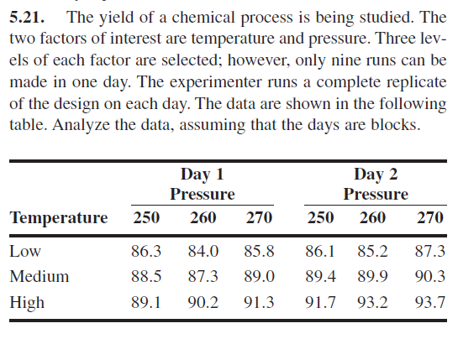

|  |
| --- |
| ***Two-way ANOVA for Chemical Yield Experiment*** |
| ***y = Yield, x1 = Temp, x2 = Pressure, x3 = Day*** |

***Dependent Variable: y Yield***

| **Source** | **DF** | **Sum of Squares** | **Mean Square** | **F Value** | **Pr > F** |
| --- | --- | --- | --- | --- | --- |
| **Model** | 9 | 122.8194444 | 13.6466049 | 25.69 | <.0001 |
| **Error** | 8 | 4.2500000 | 0.5312500 |  |  |
| **Corrected Total** | 17 | 127.0694444 |  |  |  |

| **Source** | **DF** | **Type III SS** | **Mean Square** | **F Value** | **Pr > F** |
| --- | --- | --- | --- | --- | --- |
| **x1** | 2 | 99.85444444 | 49.92722222 | 93.98 | <.0001 |
| **x2** | 2 | 5.50777778 | 2.75388889 | 5.18 | 0.0360 |
| **x1*x2** | 4 | 4.45222222 | 1.11305556 | 2.10 | 0.1733 |
| **x3** | 1 | 13.00500000 | 13.00500000 | 24.48 | 0.0011 |

From the above SAS output we can see that the F-Statistic for Temp is 93.98 with 2 and 8 degrees of freedom. The corresponding P-Value is less than α = 0.05 so we can conclude that the Temperature used has a significant effect on Yield.

The F-Statistic for Pressure is 5.18 with 2 and 8 degrees of freedom. The corresponding P-Value is less than α = 0.05 so we can conclude that the day effect is significant.

The F-Statistic for the interaction effect between Temp and Pressure is 2.10 with 4 and 8 degrees of freedom. The corresponding P-Value is larger than α = 0.05 so we conclude that the interaction effect between Temp and Pressure is not significant.

The F-Statistic for the Day Block is 24.48 with 1 and 8 degrees of freedom. The corresponding P-Value is less than α = 0.05 so we can conclude that the Day effect is significant.



From the above SAS generated interaction plot we can see slight interaction between our variables. However, the p-value for interaction is larger than $α=0.05$ so we conclude that interaction does not have a significant effect on the Yield.



***Levene Test for Temperature***

| **Levene's Test for Homogeneity of y Variance ANOVA of Squared Deviations from Group Means** | | | | | |
| --- | --- | --- | --- | --- | --- |
| **Source** | **DF** | **Sum of Squares** | **Mean Square** | **F Value** | **Pr > F** |
| **x1** | 2 | 9.5676 | 4.7838 | 1.58 | 0.2391 |
| **Error** | 15 | 45.5179 | 3.0345 |  |  |

***Levene Test for Pressure***

| **Levene's Test for Homogeneity of y Variance ANOVA of Squared Deviations from Group Means** | | | | | |
| --- | --- | --- | --- | --- | --- |
| **Source** | **DF** | **Sum of Squares** | **Mean Square** | **F Value** | **Pr > F** |
| **x2** | 2 | 115.8 | 57.8900 | 1.11 | 0.3564 |
| **Error** | 15 | 785.2 | 52.3476 |  |  |

***Levene Test for Day***

| **Levene's Test for Homogeneity of y Variance ANOVA of Squared Deviations from Group Means** | | | | | |
| --- | --- | --- | --- | --- | --- |
| **Source** | **DF** | **Sum of Squares** | **Mean Square** | **F Value** | **Pr > F** |
| **x3** | 1 | 47.6939 | 47.6939 | 1.12 | 0.3061 |
| **Error** | 16 | 682.6 | 42.6619 |  |  |

From the above Levene’s Test for Homogeneity and the SAS generated residual plots we can conclude that the residuals for all factors are constant.

***Normal Tests for Chemical Yield Experiment***

| **Tests for Normality** | | | | |
| --- | --- | --- | --- | --- |
| **Test** | **Statistic** | | **p Value** | |
| **Shapiro-Wilk** | **W** | 0.978457 | **Pr < W** | 0.9327 |
| **Kolmogorov-Smirnov** | **D** | 0.099866 | **Pr > D** | >0.1500 |
| **Cramer-von Mises** | **W-Sq** | 0.041511 | **Pr > W-Sq** | >0.2500 |
| **Anderson-Darling** | **A-Sq** | 0.232961 | **Pr > A-Sq** | >0.2500 |

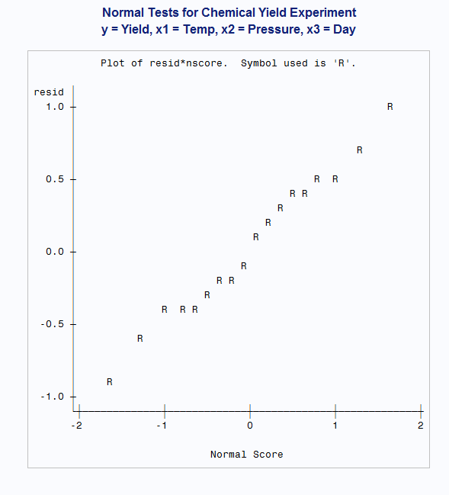

From the above SAS generated normality plot and the Shapiro-Wilk test we can conclude that the residuals for our experiment are normally distributed. Since all mode assumptions are satisfied, we will move on the Tukey multiple comparison.

|  |
| --- |
| ***Tukey Multiple Comparison Pressure Level Means*** |
| ***y = Yield, x1 = Temp, x2 = Pressure, x3 = Day*** |

|  |  |
| --- | --- |
| **Alpha** | 0.05 |
| **Error Degrees of Freedom** | 8 |
| **Error Mean Square** | 0.53125 |
| **Critical Value of Studentized Range** | 4.04095 |
| **Minimum Significant Difference** | 1.2024 |

| **Comparisons significant at the 0.05 level are indicated by ***.** | | | | |
| --- | --- | --- | --- | --- |
| **x2 Comparison** | **Difference Between Means** | **Simultaneous 95% Confidence Limits** | |  |
| **250 - 270** | -1.0500 | -2.2524 | 0.1524 |  |
| **250 - 260** | 0.2167 | -0.9858 | 1.4191 |  |
| **260 - 270** | -1.2667 | -2.4691 | -0.0642 | *** |

|  |
| --- |
| ***Tukey Multiple Comparison for Temperature Level Means*** |
| ***y = Yield, x1 = Temp, x2 = Pressure, x3 = Day*** |

|  |  |
| --- | --- |
| **Alpha** | 0.05 |
| **Error Degrees of Freedom** | 8 |
| **Error Mean Square** | 0.53125 |
| **Critical Value of Studentized Range** | 4.04095 |
| **Minimum Significant Difference** | 1.2024 |

| **Comparisons significant at the 0.05 level are indicated by ***.** | | | | |
| --- | --- | --- | --- | --- |
| **x1 Comparison** | **Difference Between Means** | **Simultaneous 95% Confidence Limits** | |  |
| **med - high** | -2.4667 | -3.6691 | -1.2642 | *** |
| **low - high** | -5.7500 | -6.9524 | -4.5476 | *** |
| **low - med** | -3.2833 | -4.4858 | -2.0809 | *** |

From the above SAS output we can see that for the Pressure Factor the Tukey Critical Value is 4.04095 with degrees of freedom 3 and 8 and the MSD is 1.2024. We can see that the mean difference between Pressure level **260 – 270 =** 0.3167. This difference is significant according to the Tukey MSD.

From the above SAS output we can see that for the Pressure Factor the Tukey Critical Value is 4.04095 with degrees of freedom 3 and 8 and the MSD is 1.2024. We can see that all mean differences are significant according to the Tukey MSD.

l